TRUVELOP APP WITH ZAPIER
Zapier is a tool that helps you to automate tasks between web apps. Zapier automatic workflows, which we call Zaps—send information from one app to another. So for Truvelop, this means that conversations that are taking place in Truvelop can also be documented in another app, such as Teams or Slack, making it easier than ever to share real-time performance and development feedback.

- How to Create Truvelop Zap with Slack:
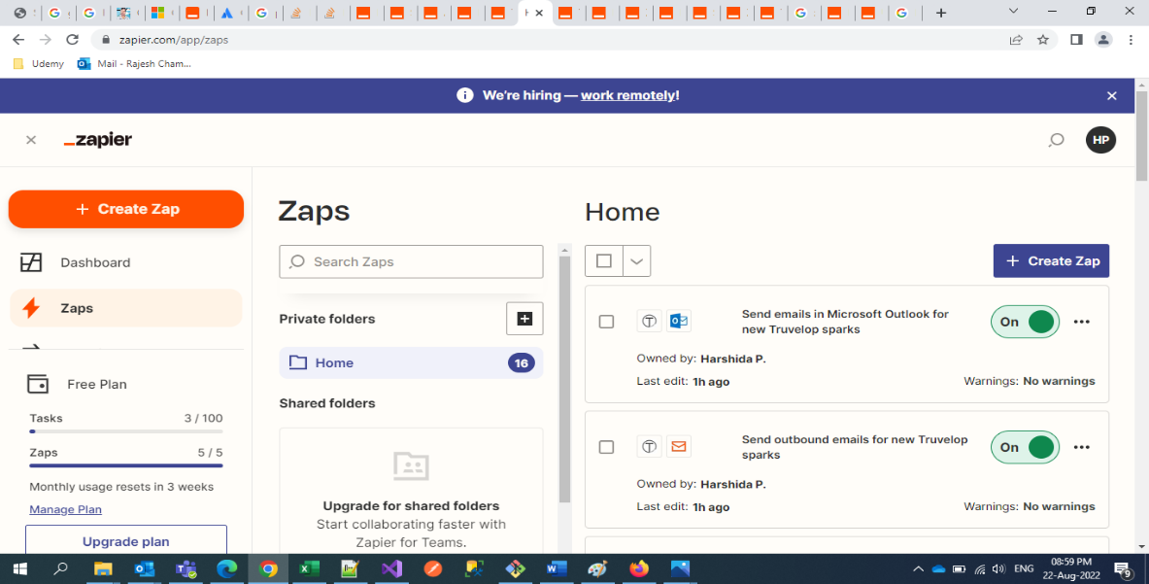
- Step 1: Login your Zapier Account and click on “Zaps”.

- Step 2: Click on the “Create Zap” button. Search for the Truvelop App and select it.
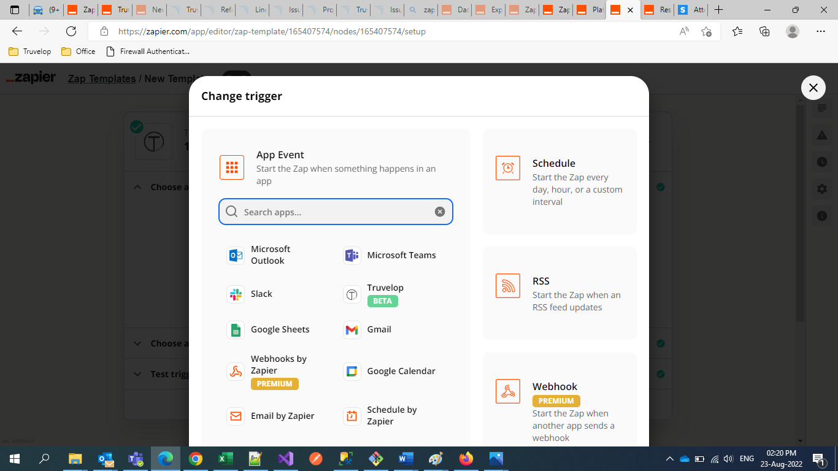

- Step 3: Select Truvelop as the App. For the event, type in “New Spark.” Click “Continue”.

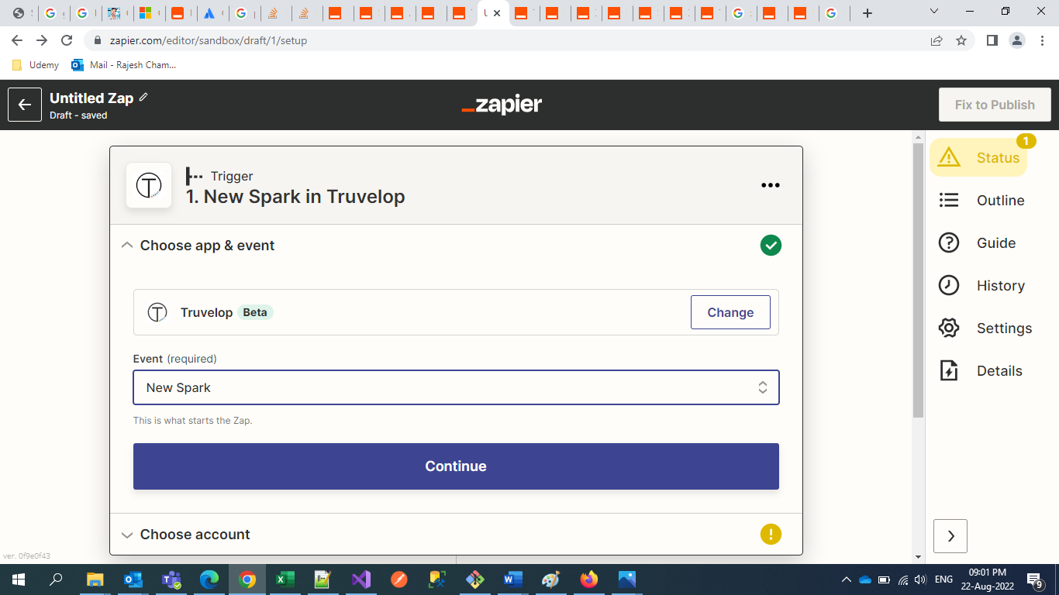

- Step 4: You'll now need to connect your Truvelop account. If you have already connected Truvelop to Zapier before, just click on the dropdown menu to select your account.
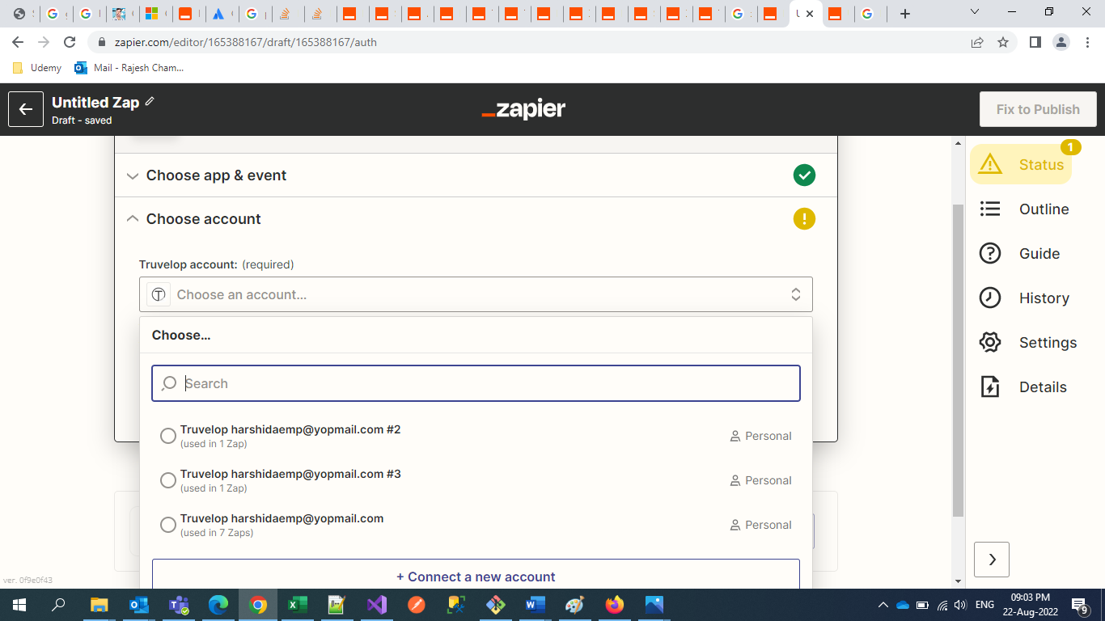

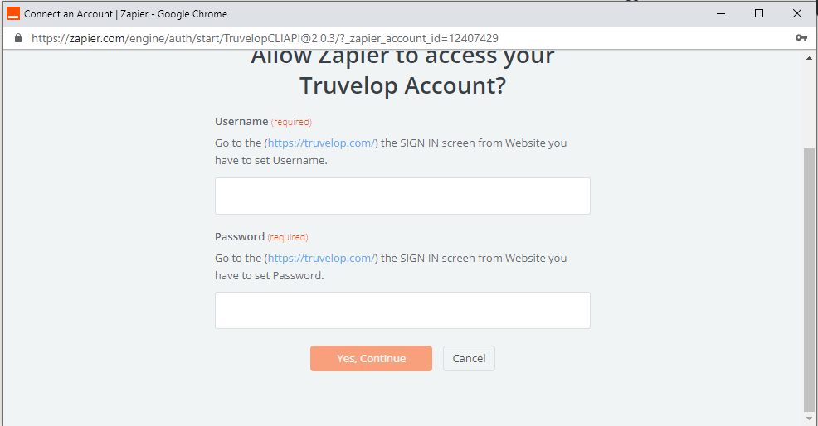
- Step 5: If you haven't, you'll click “Add New Account”. You'll then be directed to your web browser to give Zapier permission to access your Truvelop account. Once you've input your Truvelop account details, select “Yes, Continue”.

- Step 6: Select the form you want to use, click “Continue”, and then test your trigger. Zapier will look for a recent form submission (Spark), which we'll use to create the rest of our Zap. Once your test is successful, “Click Continue” to move on to the next step.
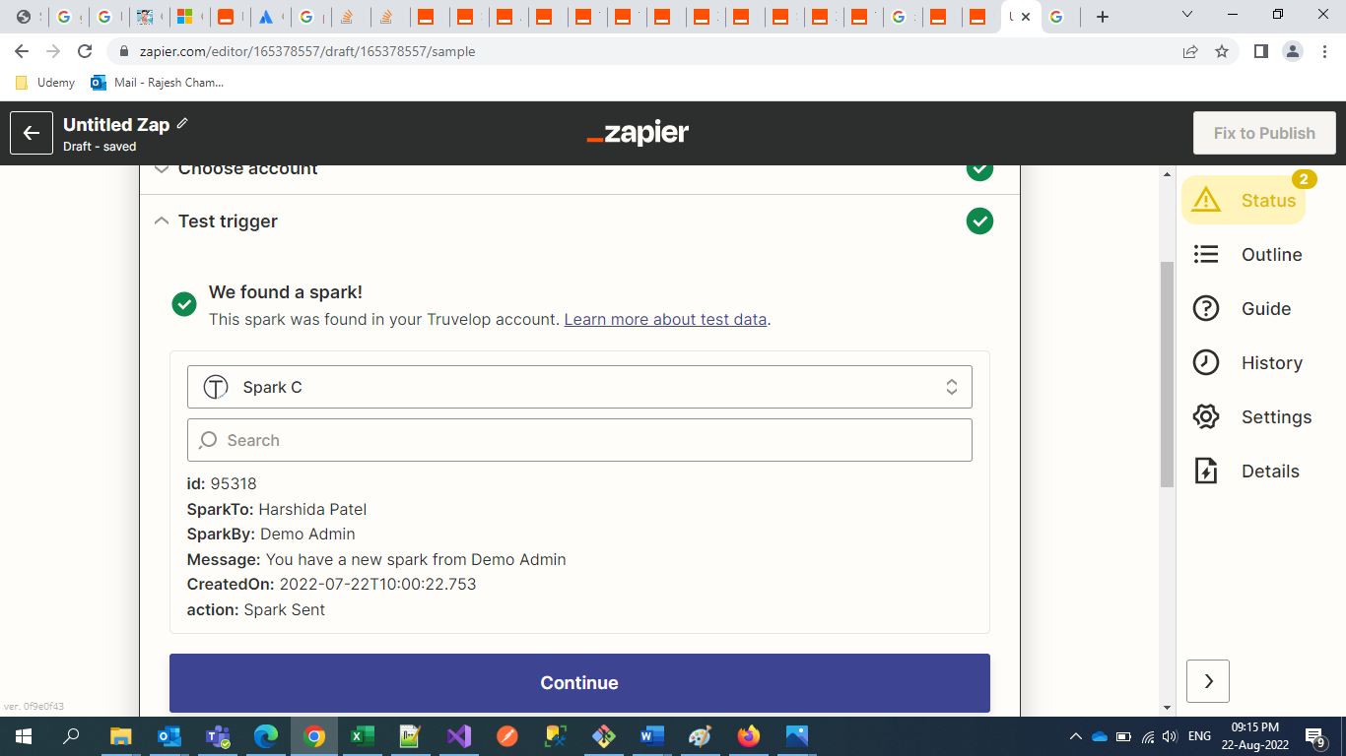
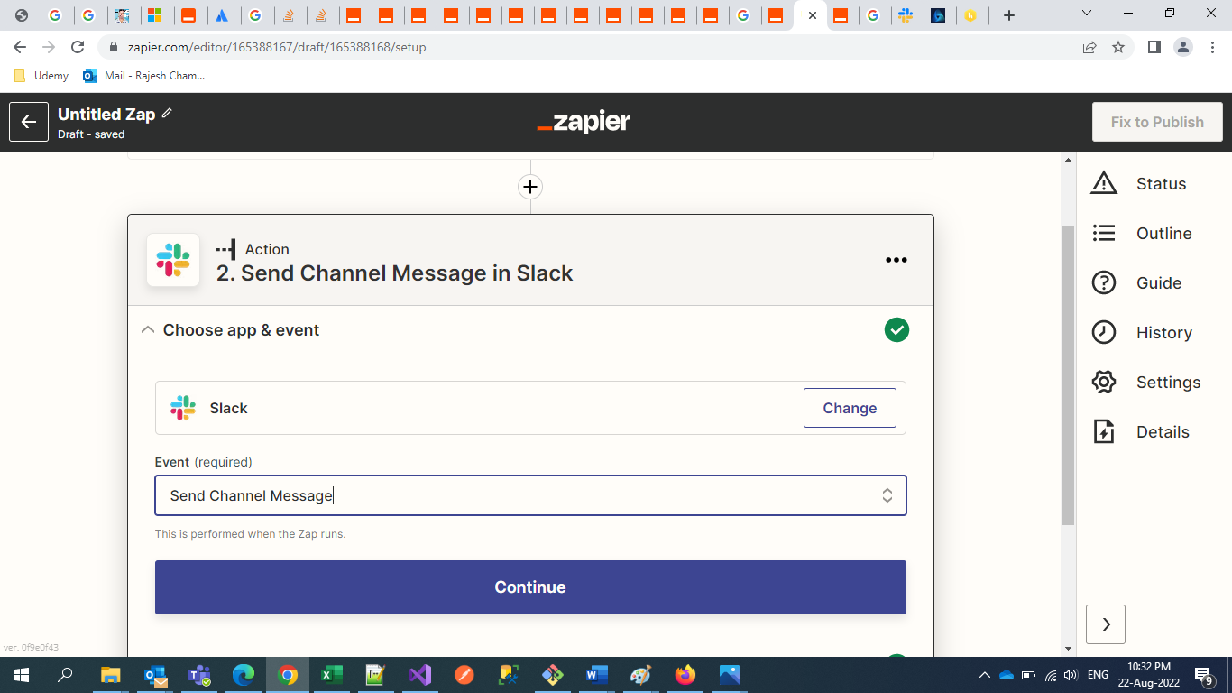
- Step 7: Now we'll create our action—the event our Zap will perform once it's triggered. If you're working off of a Zap template, the App and Action Event will be pre-selected. If you're building a Zap from scratch, search for Slack and select it. Choose the Action Event that you want. Click “Continue”.
- Step 8: Now you will add your Slack Account. Click “Continue” again once you’ve entered the details.
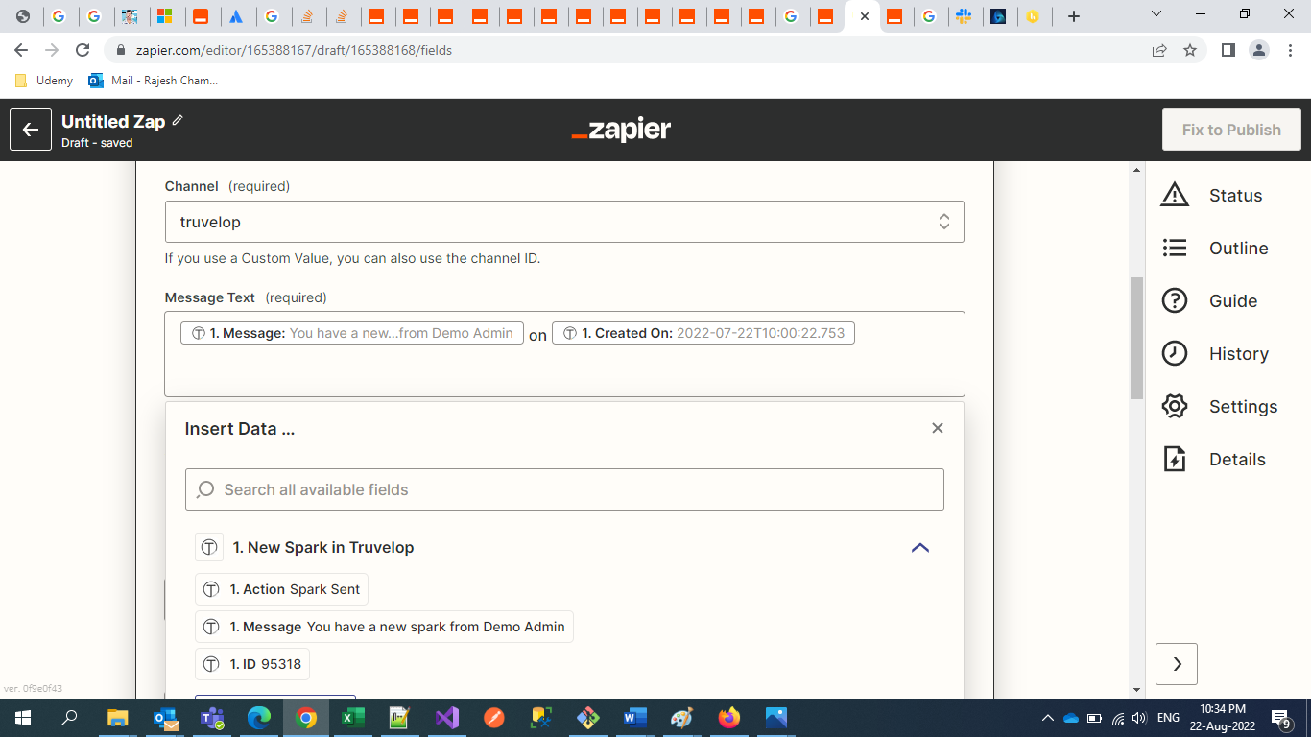
- Step 9: Customize the message to your liking using the response fields, your own text, and Zapier's formatting options. You can use Truvelop Trigger Response information as placeholders or type in your own text that will appear each time your Zap runs, or a combination of the two. When you're done formatting your message, click “Continue”.
- Step 10: Once you have customized the text to your liking, click “Continue”.
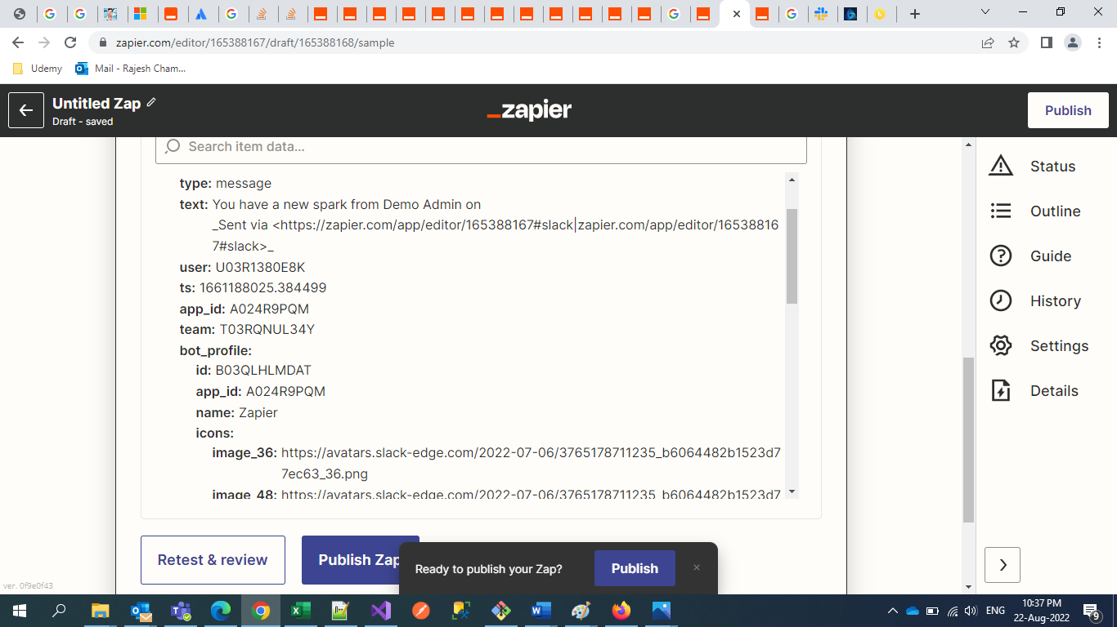
- Step 11: After you’ve tested, continue to publish the zap.

How to Create Truvelop Zap with Microsoft Teams :

- Step 1: Before we get started: Install the Zapier app on Microsoft Teams for this installation:

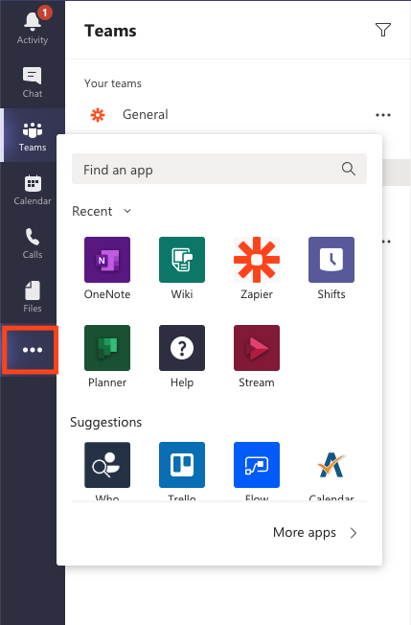
- Step 1.1: In your Microsoft Teams workspace, click on the three little dots located on the left-hand navigation bar. Type in Zapier in the search bar to find the app and click on it.
Click Here

- Step 1.2: Once you click on the Zapier app, it will bring up a pop-up window allowing you to install the app for yourself. Click “Add for me”.
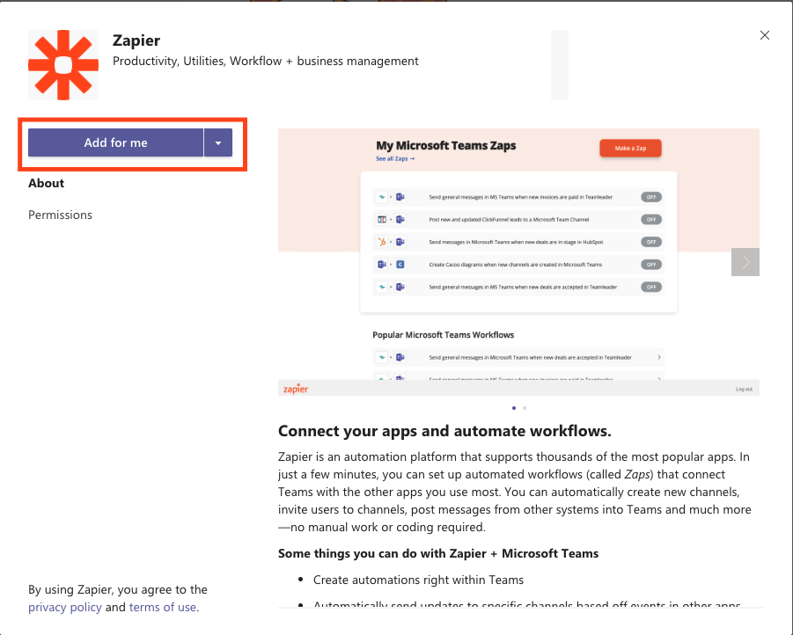

- Step 1.3: If you're an admin for your team workspace, click on the upside-down triangle and click on “Add for Team” if you'd like to install the app for your entire workspace.
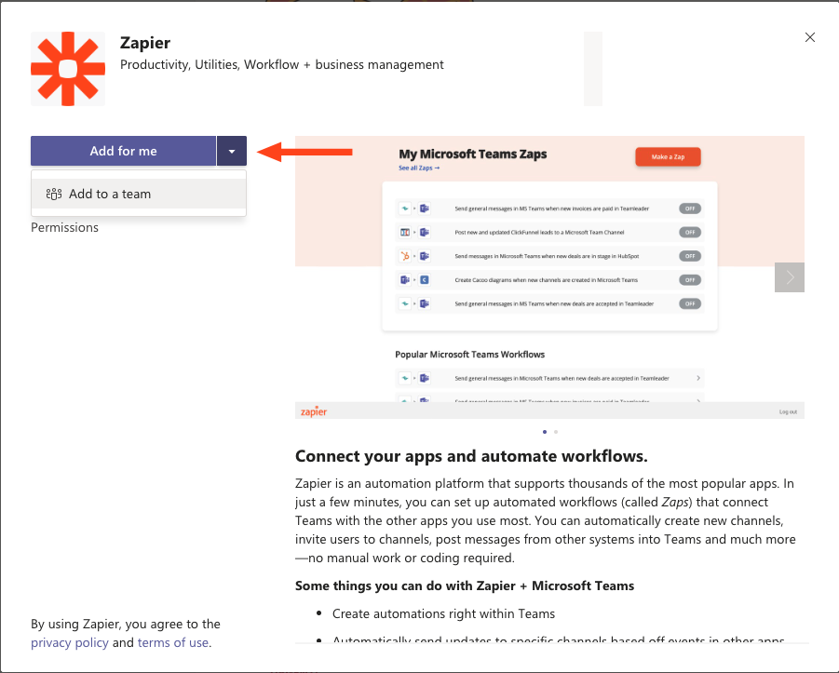
- Step 1.4: After you've added the Zapier app, it'll direct you to the app page, where you can start creating a Zap from scratch, or pick from suggested Zap templates—our pre-built automated workflows—to start automating tasks in Microsoft Teams.
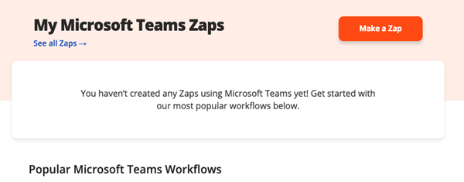

- Step 2: Repeat 1 to 6 steps [Slack steps] to connect with the Truvelop Account.

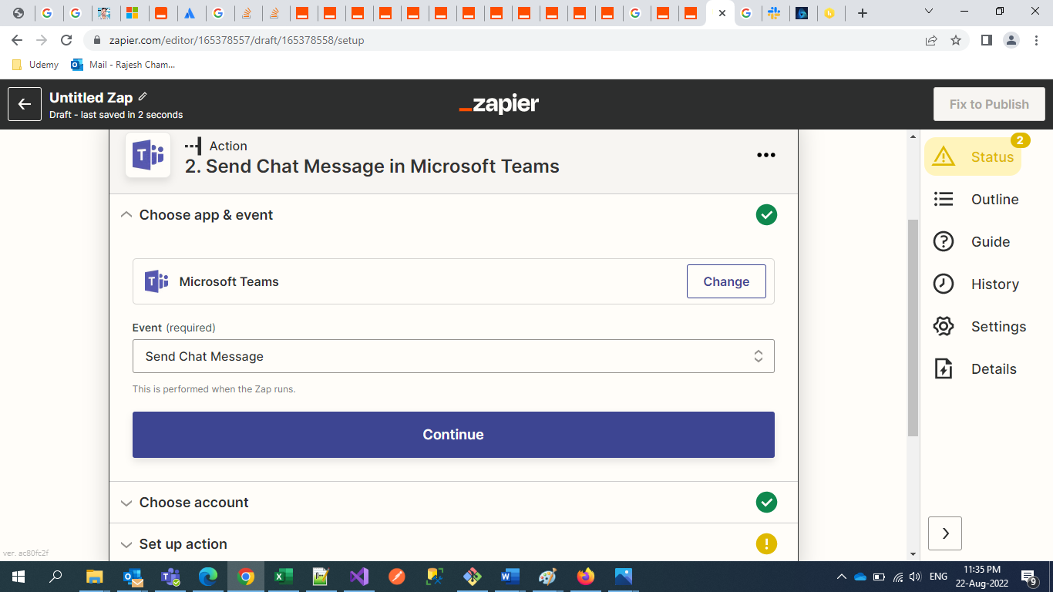
- Step 3: Now we'll create our action—the event our Zap will perform once it's triggered. If you're working off a Zap template, the App and Action Event will be pre-selected. If you are building a Zap from scratch, select Microsoft Teams as your app and Send Chat Message as the event. Click
“Continue” once you’ve entered the details.
- If you've connected your Microsoft Teams account to Zapier before, you can select your workspace from the dropdown menu.

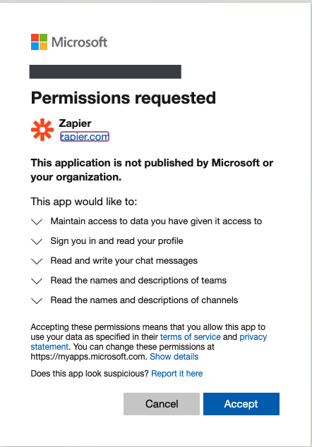
- Since this is our first-time connecting Teams to Zapier, we'll need to click on “Add New Account”. Again, Zapier will request permission access to Microsoft Teams. Click “Accept”.

- Now it's time to customize our message text. Click inside the Message Text field to start formatting your message.
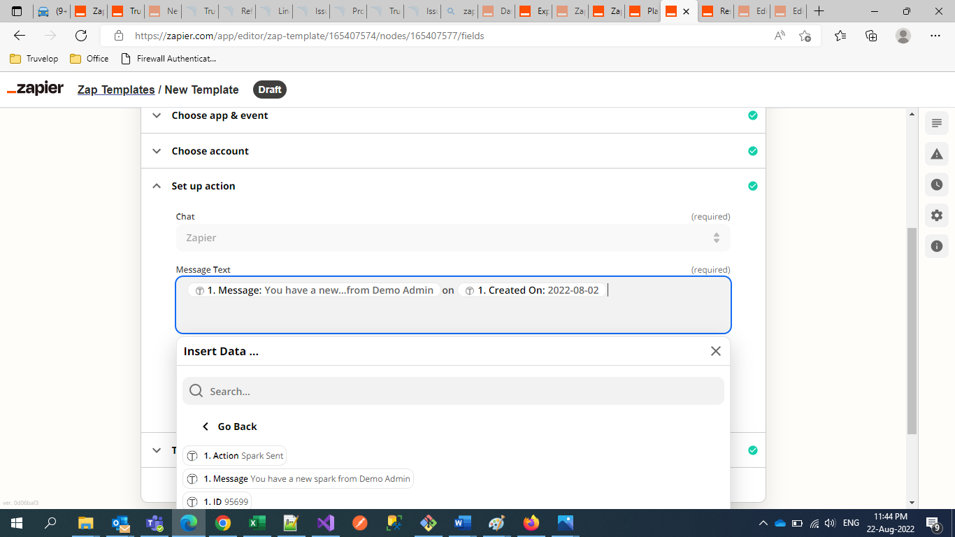
- You can use Truvelop Trigger Response information as placeholders or type in your own text that will appear each time your Zap runs, or a combination of the two. When you're done formatting your message, click Continue.
- Now it’s time to “Test the Zap”. Zapier will create a new message in Microsoft Teams.
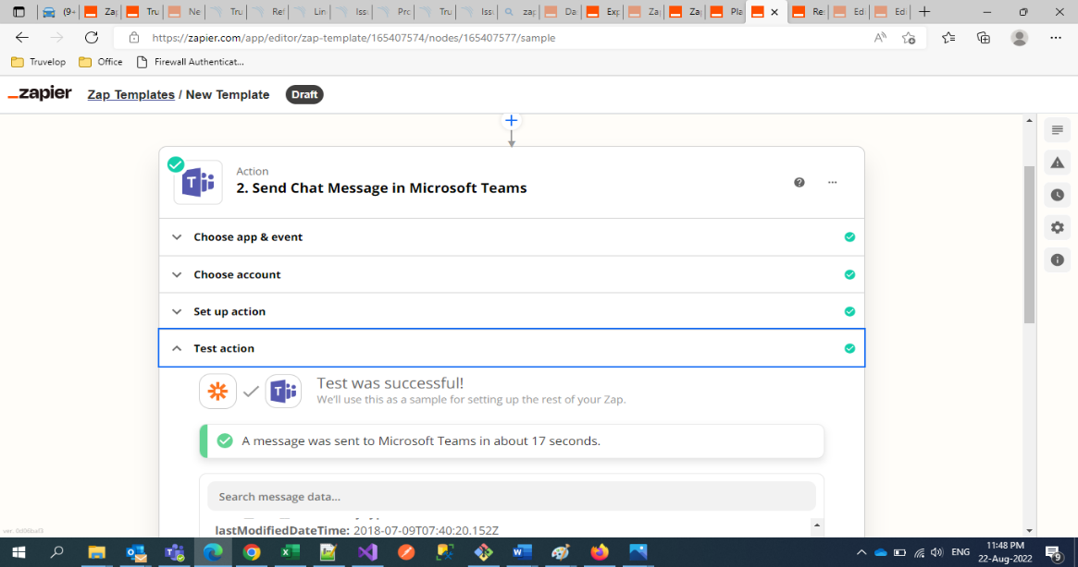
- You can always skip the test by clicking Skip Test, but if you want to make sure the preview is showing up properly, you can always click to test. Click any of the test buttons to continue.
- Once everything is set up correctly, Publish the Zap and you're ready to begin using your Zap.

- The other way to create a zap:

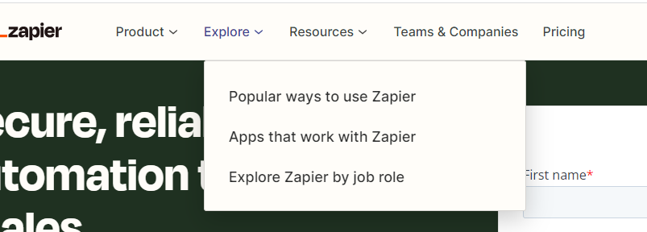
- Go to https://zapier.com/ and select the “Apps that work with Zapier” from Explore Menu.

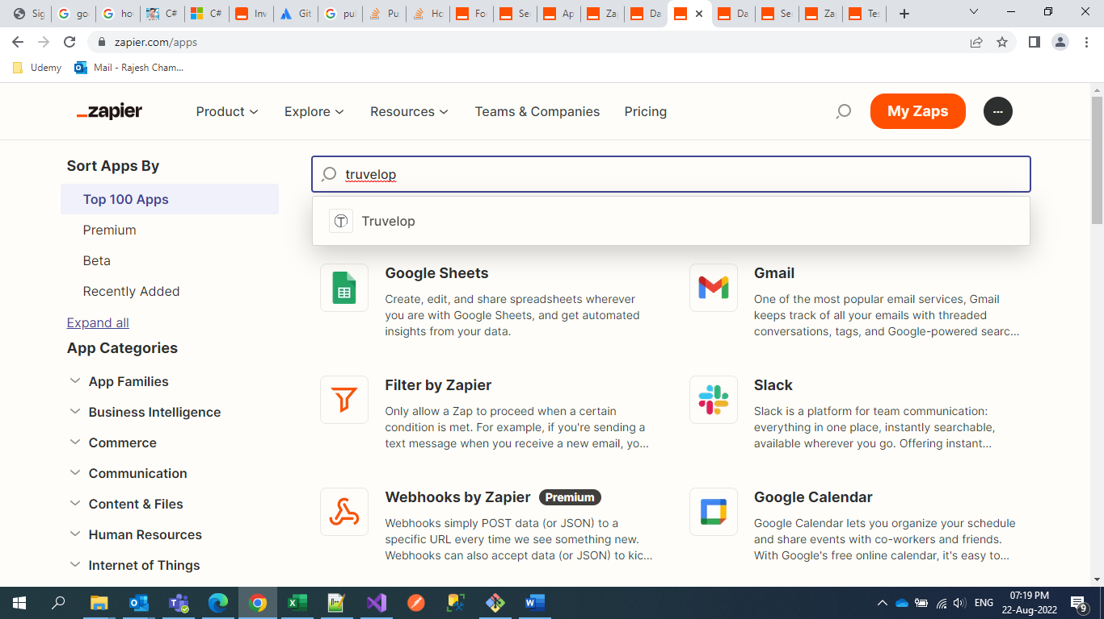
- Search the Truvelop Application.
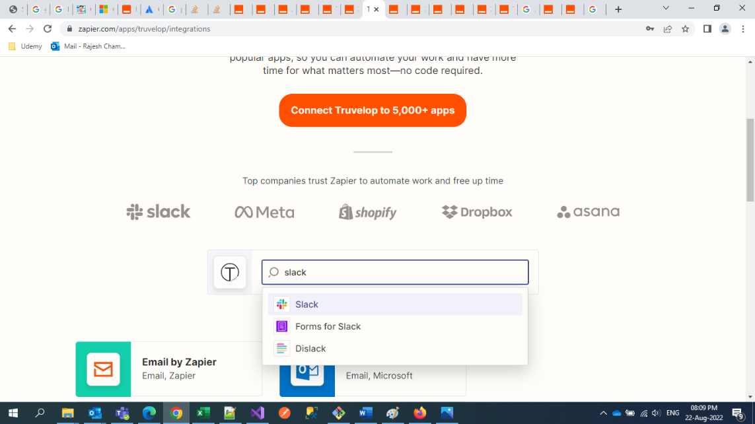
- Click on the predefined Zap template or search the app like.
- This way you can also used the Truvelop integration with other Zapier apps.

